Exercise 1.
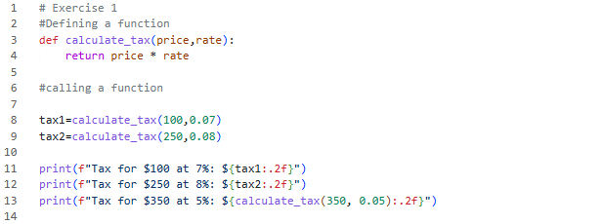

Exercise 2.
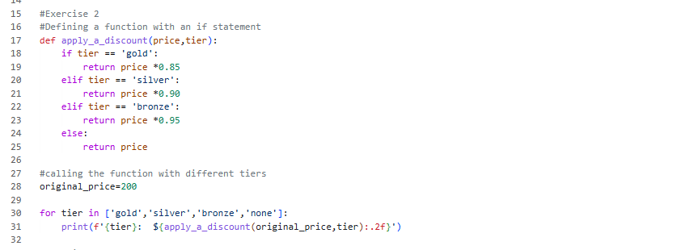

Exercise 3. 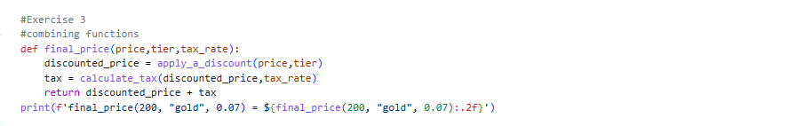

Exercise 4. 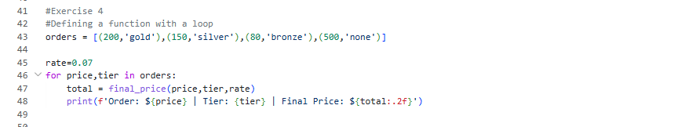

Exercise 5. 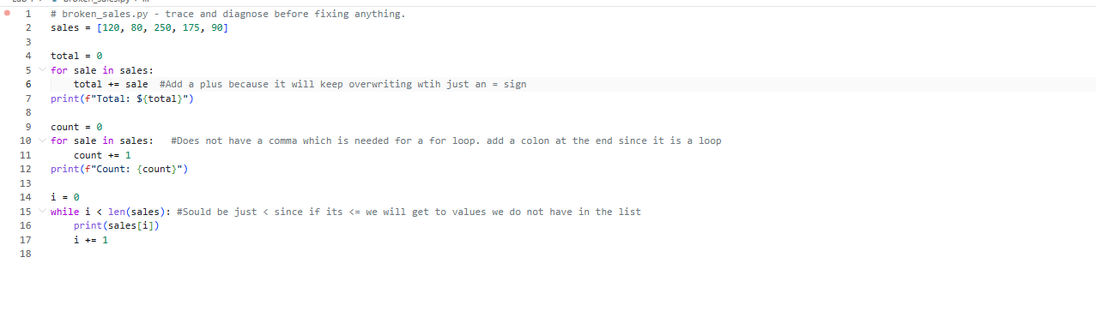

Exercise 6. 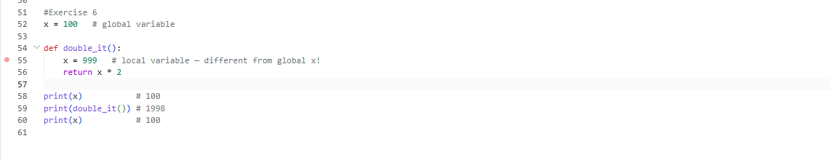

Self-assement
The first bug I saw was very simple being the for sale in sales one. Since last unit we were working very closely with that unit I saw that it orignialy only had total = sales instead of total+= sales so fixed that witout running the code or asking ai. I guess it tells me that my current debugging techniqe is based of past expericnes coding so I know where some errors are.

2.) apply_discount(price, tier) calls the function appply discount. It uses inputs of price and tier that you input to apply them to some caluclation in apply_discount function.

3.) Did not use ai in any part of the lab today

